**Steady-State Behavior of RLC in a DC Circuit**

**Lab 7**

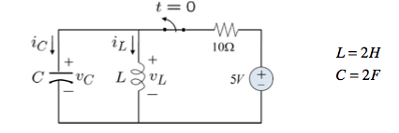

ECE 1101 Lab, Section 6

Date: Thursday, October 10th, 2019

Kyler Martinez, Daniel Tan

Equipment Used In The Experiment:

* Keysight Triple Output DC Power Supply
  + Make/Model: E3630A
  + Serial Number: MY56186189
* Keysight 4 ½ Digital Display Multimeter
  + Make/Model: U3401A
  + Serial Number: MY56150032

Materials Used In The Experiment:

* Breadboard
* 1 mH and 10 mH inductor
* 220 µF and 470 µF capacitor
* 220 Ω, 330 Ω, and 1 kΩ resistor

Objective:

Observing how inductors and capacitors behave in a steady-state DC circuit. Then, show how I=C dV/dt and V=L dI/dt for capacitors and inductors in a steady-state condition. Finally, determine the energy in the capacitors and inductors.

Background Theory:

The background theory used in the lab is that capacitors work as open circuits and inductors act as shorts while in steady-state behavior. The other theory used is that the energy in each component can be calculated by E=.5*V2*C for capacitors and E= .5*I2*L for inductors.

Procedure: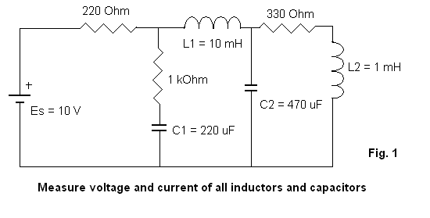

To complete the lab we had to set up our breadboard as shown in figure 1 and then measure the current and voltage going through or dropping for each of the inductors and capacitors. We then measured the true values of our inductors and capacitors and then calculated the energy stored in the elements.

Data:

Component Measured Values

|  |  |  |  |  |  |  |  |
| --- | --- | --- | --- | --- | --- | --- | --- |
| Plate Value | 220 Ω | 1 kΩ | 330 Ω | 220 µF | 470 µF | L2=1 mH | L1=10 mH |
| Measured Value | 218.47 Ω | .9965 kΩ | 329.65 Ω | 181 µF | 320 µF | .963 mH | 10.1 mH |

Measured Values

|  |  |  |  |  |
| --- | --- | --- | --- | --- |
| Component | I | V | W | Internal Resistance |
| Capacitor C1 | 3 µA | 6.172 V | .003 J | N/A |
| Capacitor C2 | .33 µA | 5.797 V | .0054 J | N/A |
| Inductor L1 | 17.095 mA | 377.36 mV | 1.47 µJ | 23 Ω |
| Inductor L2 | 17.156 mA | 61.67 mV | .1417 µJ | 3.5 Ω |

Conclusion:

The results of our lab showcase that the capacitors store much more energy than the inductors. Our results also show that the current going through capacitors is close to zero, and the voltage drop of inductors is either small or close to zero. For the inductors, we have a measured internal resistance that accounts for the voltage drop across the components. Other factors that have caused our values to be different are the machines fluctuating in reading for both our multimeter and our power supply. Depending on the time we record this information, our values can be slightly different. Another potential factor is that we may not have waited long enough after applying a voltage source to our circuit before taking measurements. The lab manual said to wait a few minutes and we may not have waited long enough which could have affected our results.

**Post Lab**

Circuit Anlaysiss By Hand

Ideal Analysis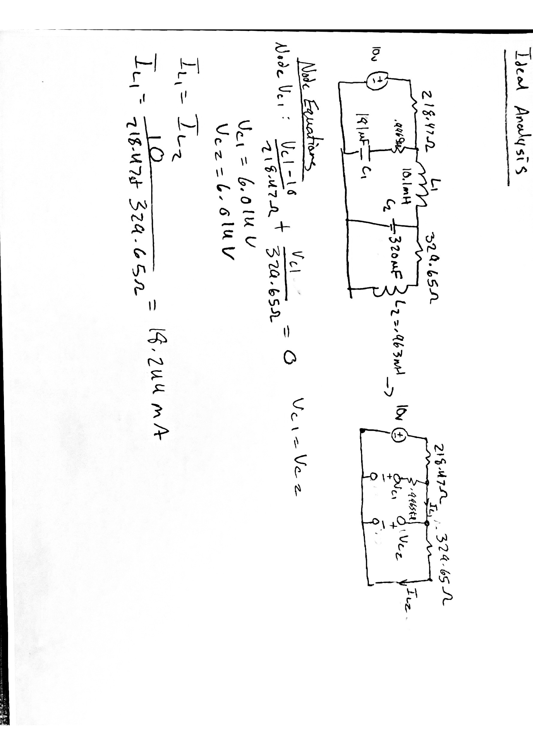

Node Equations:

Node C1: (Vc1-10)/(218.47) + (Vc1)/(329.65) = 0

Vc1=Vc2=6.014 V

Il1=Il2

IL1=(10)/(218.47+329.65)= 18.244 mA

Realistic Analysiss

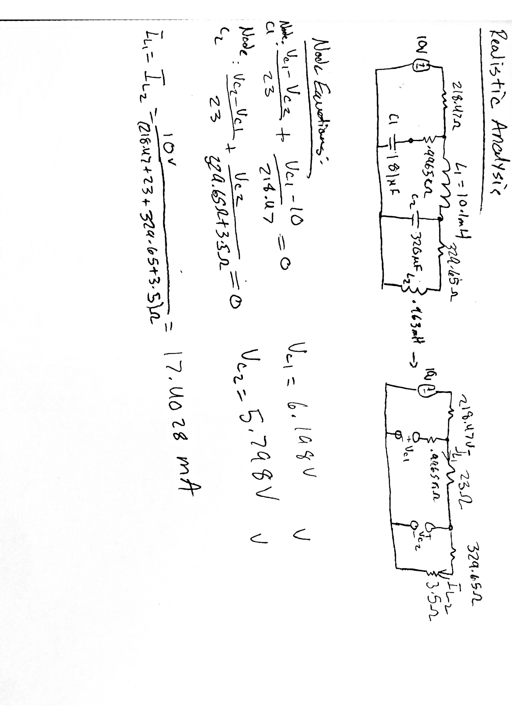

Node Equations:

Node C1: (Vc1-Vc2)/(23) + (-10 + Vc1)/(218.47) = 0

Node C2: (Vc2-Vc1)/(23) + (Vc2)/(329.65+3.5) = 0

Vc1= 6.198 V

Vc2=5.798 V

Il1=Il2

IL1=(10)/(218.47+329.65+23+1.5) = 17.4028 mA

PSPICE Simulation

Ideal Simulation

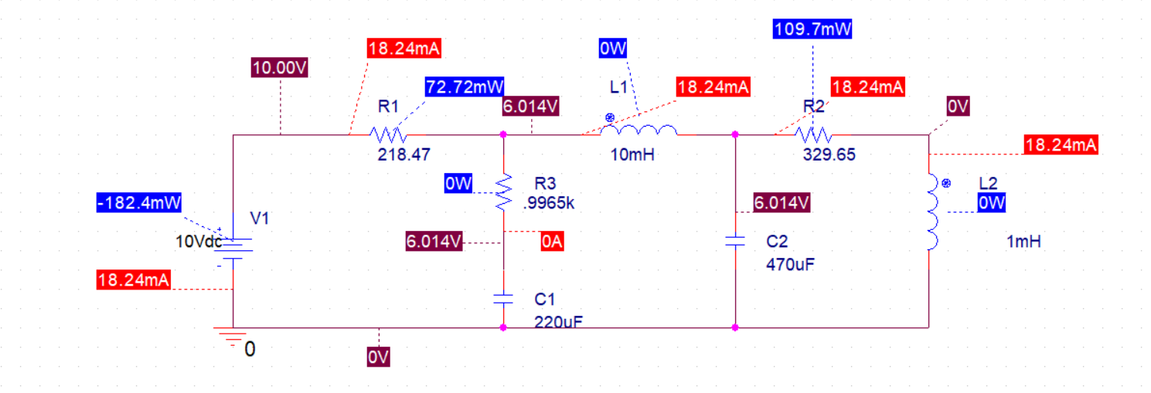

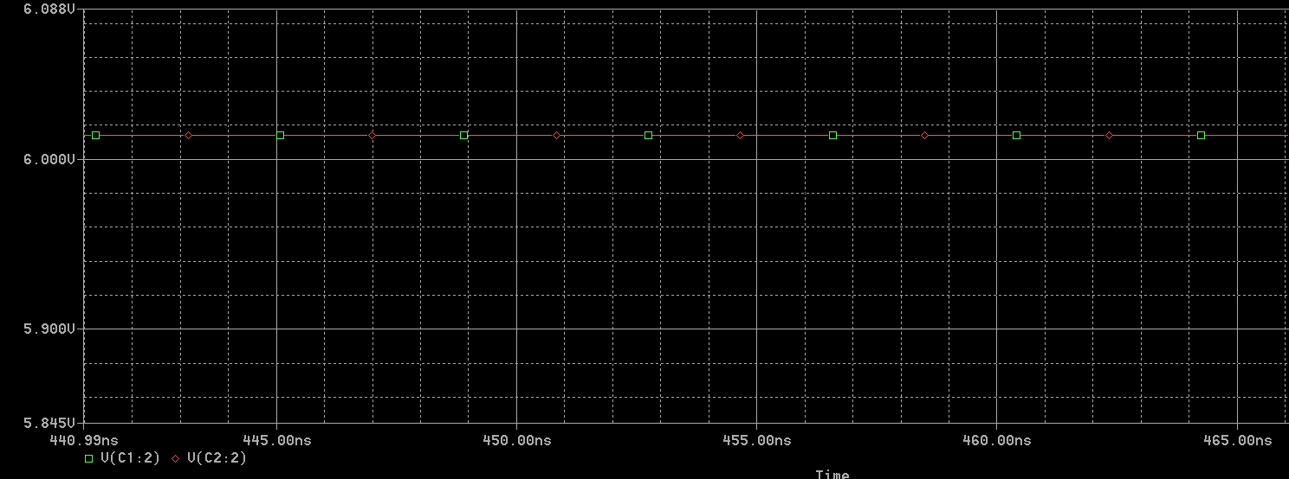

Realistic Simulation

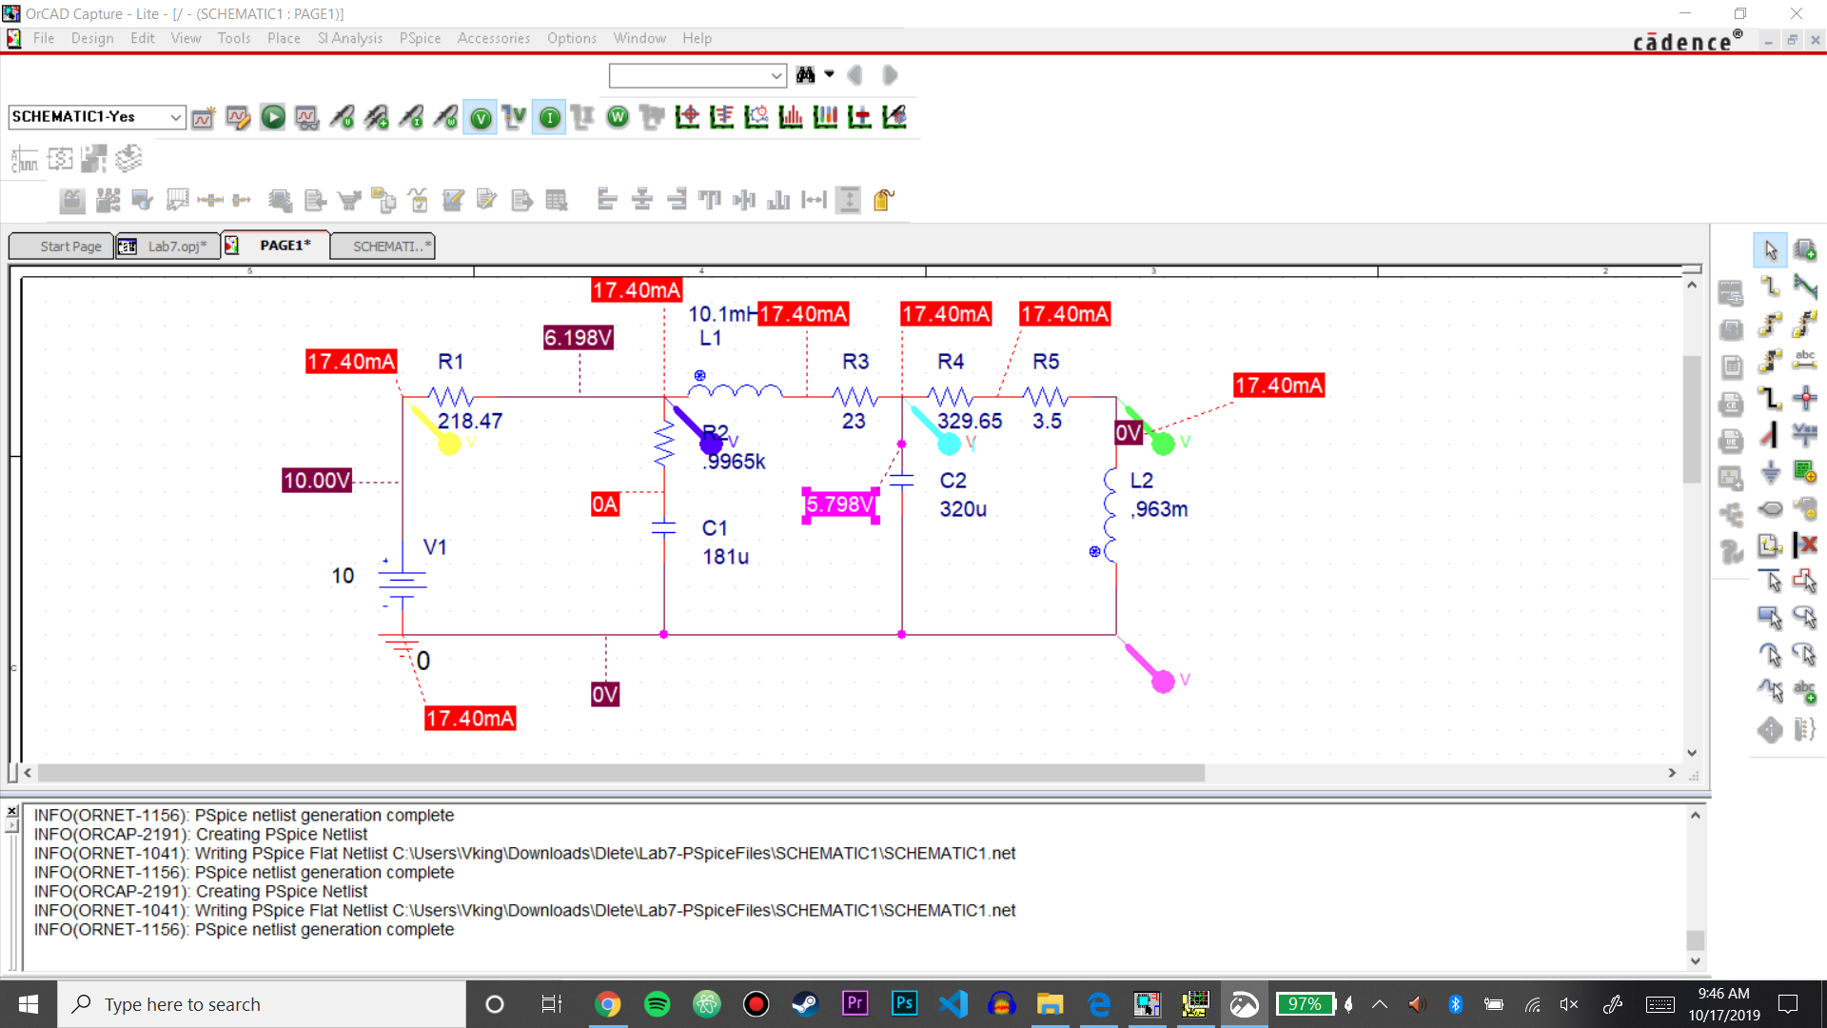

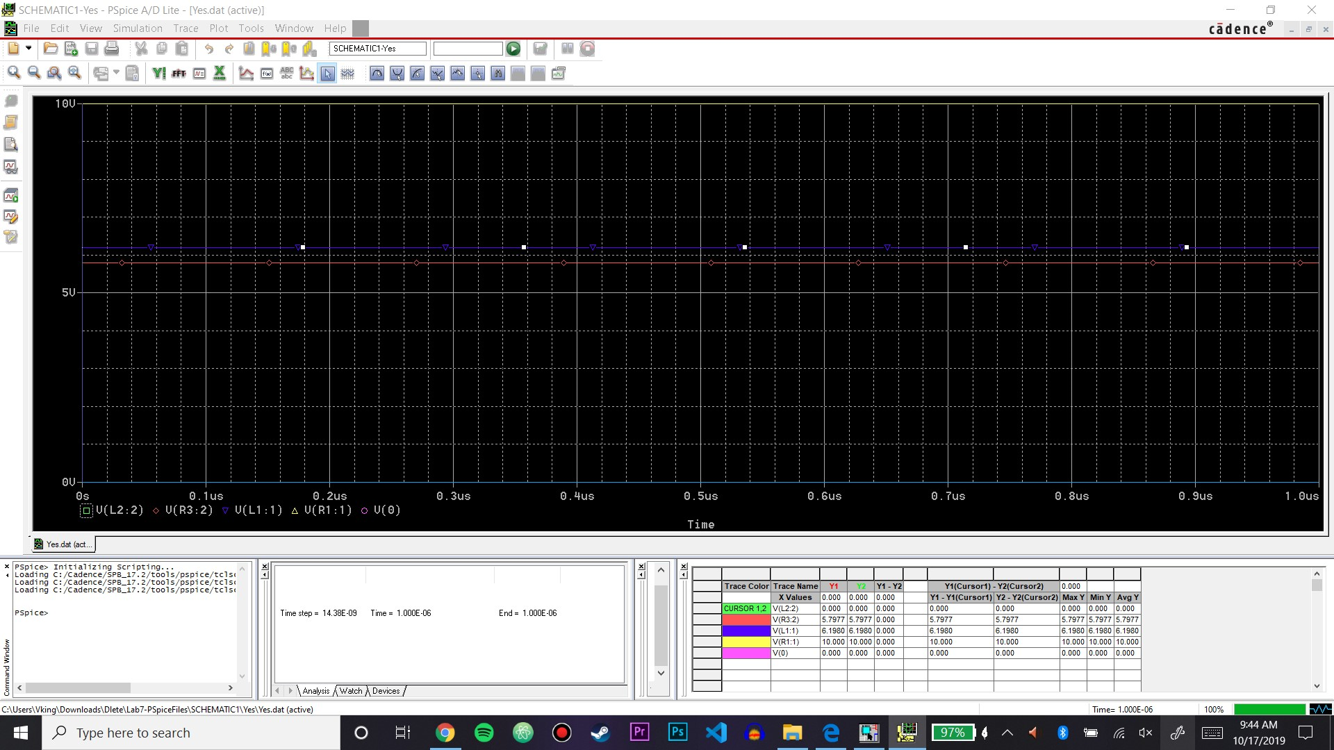

Summary Table

|  |  |  |  |  |
| --- | --- | --- | --- | --- |
| Measured | VC1= 6.172 V | VC2= 5.797 V | IL1= 17.095 mA | IL2= 17.156 mA |
| Ideal Calculation | VC1= 6.014 V | VC2= 6.014 V | IL1= 18.244 mA | IL2= 18.244 mA |
| Realistic Calculation | VC1= 6.198 V | VC2= 5.798 V | IL1= 17.4028 mA | IL2= 17.4028 mA |
| Ideal Simulation | VC1= 6.014 V | VC2= 6.014 V | IL1= 18.24 mA | IL2= 18.24 mA |
| Realistic Simulation | VC1=6.198 V | VC2= 5.798 V | IL1=17.40 mA | IL2= 17.40 mA |
| Discrepancy | 1.1423% | 2.459% | 3.773% | 3.654% |

Conclusion:

Overall by using the internal resistance and measured values from our components, our simulation and calculations resembled our measured data much more closely than the theoretical values. The capacitor C1 didn’t change too much within the realistic values while the capacitor C2 changed by a fair amount when the internal resistance was accounted for in the simulation but was much closer to our original values. The currents didn’t change much when the internal resistance was accounted for, but this is due to the internal resistance being low values. Our percent differences can be attributed to not allowing the circuit to reach steady state before tsking measurements, and there could be some problems with the internals of the components which could affect our data measurements.